Briefing Note 13: Mains Location Arrangements For UIP/IGT Connections
Version 5.1
January 2023

Table of Contents
1) Introduction 3
2) Purpose 3
3) Contacts 3
4) Definition 4
5) When will WWU fund costs? 4
6) What will WWU fund? 6
7) Reporting a mains location error to WWU 8
8) Laying additional pipe work 10
9) Change of connection diameter / material 11
10) Time Scales 12
11) Payment and Evidence 12
12) Appendices 14
Example A – Larger Main Found 14
Example B – Shorter Main Found 15
Example C – Smaller Main Found 16

- Introduction
This briefing note was first issued in December 2005 and was designed to provide clarity on the various roles and responsibilities when Wales & West Utilities (WWU) records do not match what is identified on-site.
There are contractual terms in place which specify the commercial arrangements between WWU and a Utility Infrastructure Provider (UIP) or Independent Gas Transporter (IGT). This briefing note aims to provide further guidance on the process of reporting a mains location error and how it will be addressed but does not supersede the overarching agreement.
- Purpose
WWU has a duty to maintain accurate records of where assets are located but that a degree of inaccuracy may exist, particularly for legacy pipe work, installed before 2005. Therefore, WWU commits to working with UIPs and IGTs to resolve issues as swiftly and efficiently as possible.
The purpose of this briefing note is to clearly identify the process and provide guidance which must be undertaken to report a mains location error and how the issue will be resolved. The briefing note will also set out roles and responsibilities along each stage of the process.
- Contacts
Any questions relating to this document should be directed to the following:
gtuip@wwutilities.co.uk or 3rd Party Connections, Wales & West Utilities, Spooner Close, Celtic Springs, Coedkernew, Newport, NP10 8FZ.

- Definition
A main location error occurs when an UIP or IGT cannot locate WWU apparatus. WWU can help in locating the asset in accordance with our contracted terms.
In certain scenarios, WWU will make payments to contribute towards the cost of any additional works required outside of the original project scope or construct the pipe work itself on the UIP/IGT’s behalf.
A main location error is defined as an inaccuracy between WWU’s registered mapping database and what is identified on-site. The UIP/IGT is responsible for ensuring that the latest records are obtained from https://www.linesearchbeforeudig.co.uk/ and WWU will not accept any liability where other records are being used.

- When will WWU fund costs?
Where applicable, WWU will contribute towards the difference in cost between the original scope and the new scope of works as the result of a mains location error.
All costs must be approved by WWU in advance of and prior to completing any works. Failure to consult with WWU prior to completing the works may result in no compensation being awarded.

Scenarios where WWU will contribute towards the mains location costs:
- Where the mains diameter differs from our records.
- Where the mains material differs from our records.
- Where the mains pressure tier differs from our records.
- Where the pipe is recorded as live but is dead.
- Where the main is recorded more than 3m away from its actual position (vertically or horizontally).
Scenarios where WWU will not contribute towards the mains location costs:
- Where the main is located within 3m of the recorded point (vertically or horizontally).
- Costs associated with the main being inserted within another pipe or obstructed by other apparatus e.g., breaking open a cast iron main or 3rd party utilities/highways infrastructure blocking the connection fitting.
- Where the point of connection is not feasible due to previous work on the main or fittings in situ. For example: squeeze off points or top tees etc. fused at the point of connection.
- Obstructions outside of WWU’s control e.g., parked cars or Highway Authority restrictions about where the connection can be made.
- Where the main is correctly recorded but the connection is not feasible.
- Where the network configuration has changed, and all changes were updated onto the mapping data base within thirty working days of being commissioned.

- What will WWU fund?
WWU will either construct itself or contribute towards the difference in cost between the original scope and revised scope following the main location error. The funding will apply to reasonable costs incurred and should exclude any profit/uplift.
It is recognised that errors can lead to knock on effects and additional costs so the following aims to clarify what WWU will and will not contribute towards.
The following is an indicative list of costs WWU will contribute towards:
- Street works or Permit fees associated with a delay over and above the planned works.
- Traffic management required to complete additional works over and above what was originally planned.
- Labour, materials, and reinstatement associated with laying pipe work to the original connection location, where the main is 3m away from the original recorded position (vertically or horizontally).
Additional connection costs where the incorrect records lead to different fittings being required.

The following is an indicative list of costs WWU will not contribute towards:
- Costs which would have been incurred under the original project scope.
- UIP/IGT employee expenses for overnight stay.
- Contractual liabilities between the UIP/IGT and their customer.
- ‘Down-time’ because of a delay.
- Costs for connecting/laying where the main is within 3m of the as laid record (vertically or horizontally). This includes trenching etc. required for deep excavations.
- Trial holes/slip trenches where the main is located within the 3m tolerance.
- Compensation requests arising from a delay in the connection to the site.
- Resource/planning issues because of additional works being required.
- Main location errors arising from previously adopted assets. In this scenario, additional costs may be sought from the original party who constructed the pipeline.

- Reporting a mains location error to WWU
To record a mains location error the UIP/IGT must first complete their initial excavation at the proposed connection point.
Carry out the following checks to help identify the location of the main:
- Ensure that the latest mapping records are being utilised from https://www.linesearchbeforeudig.co.uk/. Check for annotations around depth of the pipe and/or assumed routes.
- Ensure that the trench is excavated to the relevant depth for the surface category, if not found excavate to 1.2m.
- Consider if the layout of the street/road has changed and something once digitised in one area may be in another e.g., road widened so a main previously in the footpath but now in the carriageway.
- Review if any ‘scaring’ (trench or reinstatement patches) is present.
- Search for valve or siphon boxes along the route of the main.
- Attempt to locate meter boxes on nearby properties and follow logical route to the parent main.
If the main or nearby services are metallic, attempt to get a trace onto the main and follow back to the proposed connection point.
Contact WWU and confirm that the above has been completed, providing all information which will be of relevance. It is important that clear photos are taken and WWU are contacted whilst the excavation is still open to ensure that all relevant evidence is collated prior to backfilling the trench. Failure to do so may result in WWU refusing to contribute towards the potential mains location error.
WWU will review the information provided, as well as other relevant information and consider whether to suggest an alternative connection point where evidence suggests the main will be located or suggest that further works or a trial hole are completed in the current vicinity.
If the main is not present, then the UIP/IGT should proceed to:
The initial trial hole will commence by ensuring that the current excavation is extended to a depth of 1.2m. As guidance, the following excavations will then be recommended to 1.2m depth:
- Footpath Excavate the width of the footpath.
- Single Lane Road Excavate a ‘slip trench’ the width of the carriageway.
- Dual Carriageway Excavate a ‘slip trench’ the width of one single lane.
- Verge Consult with WWU on an individual basis.
Please Note: WWU can be consulted at any time during the process. Costs must be agreed prior to the works being completed and failure to do so may result in WWU not contributing towards the costs incurred.
- If the initial trial hole does not locate the main, WWU will suggest alternative locations for a second and third trial hole. It is suggested that:
- The second trial hole is located at the nearest position that the main is believed it could be located i.e., excavate existing services at expected mains connection location.
- The third trial hole is located at the nearest position where it is strongly believed that the main is located i.e., where scarring is clear, services connected or where the main tees off in another direction.
Please Note: As above, WWU must be consulted prior to completing these works.
If the main’s location still isn’t identified the next course of action will be considered on a case-by-case basis. Suggested actions include:
- Site meeting between WWU operatives and the UIP/IGT to discuss further investigatory works which could be conducted e.g., inserting a camera from a known position.
- Suggesting further trial holes be conducted.
- Suggest an alternative connection point to WWU’s network.
If WWU incur costs in locating the main and it transpires that the UIP/IGT has not completed investigatory works as agreed, WWU reserve the right to pass on costs incurred to the UIP. This includes if the main is located within the tolerance and the investigatory works are insufficient.
- Laying additional pipe work
If it has been identified that a mains location error exists and additional pipe work is required, the UIP/IGT should provide WWU with a quotation to lay the additional pipe work (inclusive of the initial 3m from the original recorded position) prior to the works taking place.
The quotation should be based upon additional costs incurred because of the change in works and not include any profit/uplift.
If applicable, the quotation should be broken down into three sections:
- Cost incurred because of the delays on-site.
- Cost of any trial hole/investigatory works completed.
- Cost of laying the additional pipe work/change in connection.

WWU will compare the quotation against the cost for its own Direct Labour Operatives (DLO) and framework contractors to complete the works and inform the UIP/IGT of its decision.
Please note: where WWU fund the cost of laying additional mains, WWU will retain ownership of that section of pipe work, regardless of whom it is constructed by.
The quotation provided must be the full and final cost. WWU will not accept additional claims once the scope/cost has been defined unless explicitly stated beforehand.
- Change of connection diameter / material
If WWU has recorded the existing main at an incorrect diameter or material WWU will contribute towards the difference in cost between the original and new connection. This may include:
- Cost in material price e.g., difference in 63mm to 90mm top tee.
- Change in connection fitting required e.g., difference from an under-pressure tee to branch saddle.
- Additional labour and reinstatement associated with a change e.g., different in costs associated with a top tee to a full insert tee with bypass points.
WWU may have to confirm if the proposed connection point is still suitable sized to connect to. If this is not the case, an alternative connection will need to be agreed.

- Time Scales
It is acknowledged delays caused on-site are time sensitive, so WWU commit to responding within the following timescales (Monday – Friday):
Item | Response By
Permission to undertake an initial trial hole | 2 hours
Permission to undertake second or third trial holes | 4 hours
Approving a change in connection point | 4 hours
Approving main location error costs <£5,000 | 1 day
Approving main location error costs <£50,000 | 2 weeks
Approving main location error costs >£50,000 | Individual basis
Make Payment | Six weeks from as laid/DR8

If WWU are to construct the pipe work associated with the location error, then the works will be programmed at the next available date. WWU has no dedicated resource to complete these works so operational resources from Connections or Replacement schemes will be utilised when capacity is available.
- Payment and Evidence
To raise a payment, the UIP/IGT must submit to WWU a formal quotation for completing the works, including the relevant payment details.
Payment will be issued within six weeks of the completion file and DR8 error reporting form being received.

The costs associated with the mains location error must be demonstrated including:
- Timesheets for labour.
- Material receipts.
- Contractor and other invoices.
- Photographic evidence.
Photographic evidence must show:
- Clear photograph providing a general understanding of what works have been completed.
- Gas Map showing location of trial holes (for example, Photograph 1 relates to Location 1 on associated gas map).
- Measurement showing the depth of the excavation.

- Appendices

Example A – Larger Main Found
Scenario: WWU records show a 4” CI main at the point of connection but the diameter transpires to be 6”:
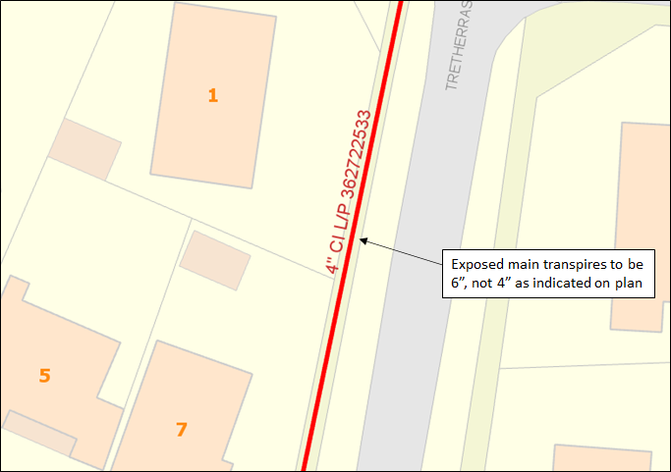
What will WWU contribute towards?
- License or Permit fees associated with a delay in the works.
- Traffic Management costs associated with a delay in the works.
- The difference in cost between a 4” connection and a 6” connection.
What won’t contribute towards?
- Downtime or employee expenses because of a delay caused in procuring the new materials or awaiting a decision from WWU.
- Contractual liabilities between the UIP/IGT and their customer.
- Labour associated with the connection cost.

Example B – Shorter Main Found
Scenario: The actual main location is 10m away from the originally agreed connection point:
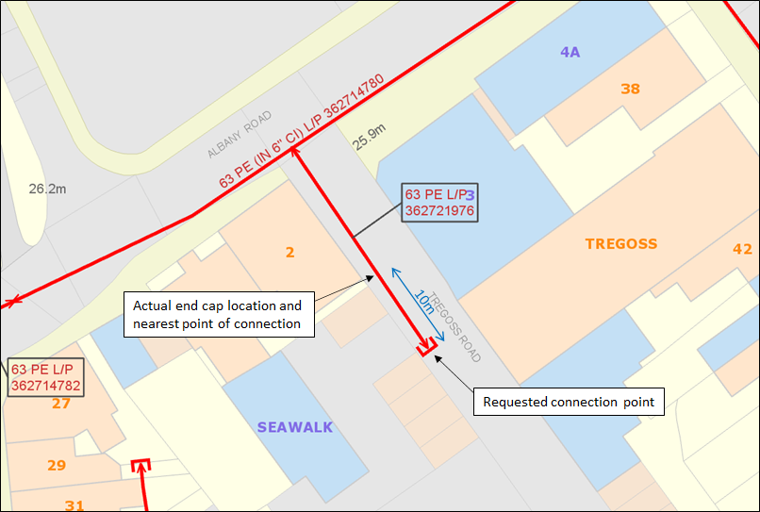
What will WWU contribute towards?
- Investigative works associated with identifying the position of the main.
- License or Permit fees associated with a delay in the works.
- Traffic Management costs associated with a delay in the works.
- Reasonable costs incurred in laying the 10m of pipe work.
What won’t WWU contribute towards?
- Downtime or employee expenses because of a delay caused in procuring the new materials or awaiting a decision from WWU.
- Contractual liabilities between the UIP/IGT and their customer.
- Labour associated with the connection cost or any mains which were required under the original scope of works.

Example C – Smaller Main Found
Scenario: The main was originally recorded as 90mm but is 32mm. The connection cannot be made from the 32mm due to capacity restrictions:
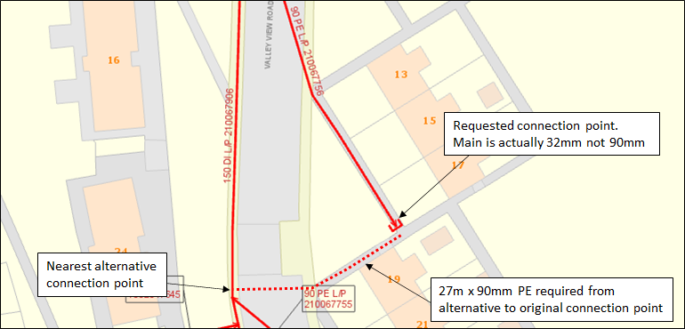
What will WWU contribute towards?
- The difference in cost between the original connection and the proposed connection.
- Reasonable costs incurred in laying additional pipe work back to the alternative connection point. If an alternative route is taken to site, the costs which would have been incurred for the original scope need to be deducted from the WWU payment.
- License or Permit fees associated with the new scope.
- Traffic Management costs associated with the new scope.
What won’t contribute towards?
- Costs associated with locating the original main/connection point.
- Contractual liabilities between the UIP/IGT and their customer.
- Labour associated with the original connection or mains under the original scope of works.
- Downtime or employee expenses because of a delay caused in awaiting a decision from WWU.

