Supplier Charter
Version 2
January 2024

Wales & West Utilities customers and communities rely on us to deliver a safe reliable gas supply to their homes and businesses every day. We are committed to being a sustainable business and our Supplier Charter sets out how our approach to responsible procurement will support that vision, sharing our expectations of how we, with the support of our supply chain will contribute positively to the society and environments in which we operate. We are determined to protect our reputation as a reputable business, and meet our obligations as set out by our regulator Ofgem.

Our future supply agreements will be developed in line with our Business Priorities and Values which define how we go about our business, enabling us to meet our sustainability ambitions.

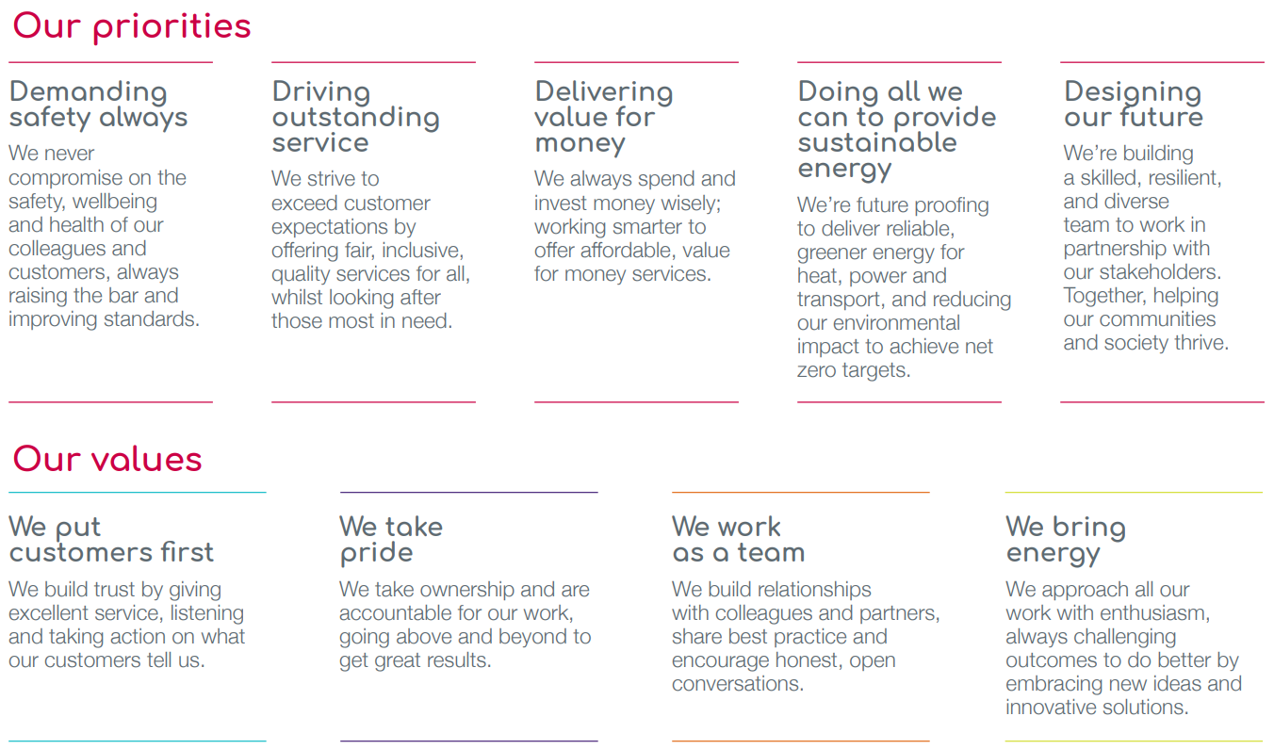

As a responsible business, we comply with all applicable laws and regulations and behave with honesty and integrity. The standards we set ourselves now and in future can only be maintained with the support of our supply partners. We will only seek to collaborate with organisations who respect our principles and share our passion for socially beneficial standards of working. We expect these organisations, their sub-contractors, and employees to adopt our principles and to hold their conduct to the highest ethical standards, while maintaining compliance with all relevant legislation.

Modern Slavery
As active members of the Slave Free Alliance (SFA), a cross industry group consisting of more than one hundred and twenty UK businesses, we aim to raise awareness and build resilience to the risks of Modern Slavery. Through this activity we contribute to the Utilities Against Slavery (UAS) working group. The UAS aims to develop Utility sector collaboration, building skills and shared resources to support SFA objectives. Wales & West Utilities aim to exceed the requirements of the Modern Slavery Act 2015, with the Procurement Policy expressly requiring our supply partners to comply with the Act. A group drawn from across the business works to develop action plans and strategies which strengthen our knowledge and systems while ensuring support at the highest level. All activity is published annually through a Modern Slavery statement. We undertake to build a clear picture of anti-slavery knowledge and activities within our supply chains and develop learning pathways to assist the creation of a resilient supply base. We will not continue to purchase goods or services from any group that is found to be complicit in human trafficking or modern slavery in any form. Anyone suspecting activity which breaches our policies can contact us in confidence through their category manager, or anonymously through Safecall on 0800 9151571 or www.safecall.co.uk/report.

The Living Wage
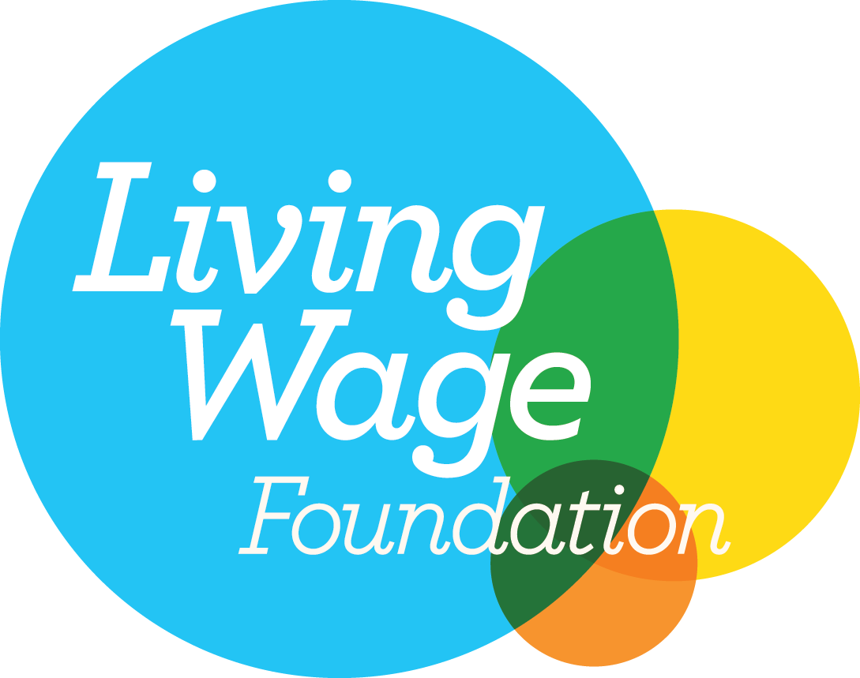
As a Living Wage accredited employer, we ensure that all our staff, whether directly employed or permanently engaged on our premises, earn at least the Real Living Wage. This standard considers a wide range a metrics, from food, retail, and housing, to determine the real cost of living and is adjusted annually. We are aware of the security that the standard provides to employees, particularly in recent times of unprecedented inflation. The standard is also shown to offer tangible benefits to employers which include improved employee satisfaction, reductions to both training and recruitment costs, as well as increased retention. We would encourage all our suppliers to become Living Wage employers and in turn, to promote the standard throughout their own supply chains.

People
We are committed to respecting and promoting human rights while adhering to the concepts of The Equality Act 2010, along with the ethos that providing decent work is a cornerstone of economic growth. Our requirements align to the core standards of the International Labour Organisation (ILO), where overarching expectations include the freedom of association and the effective recognition of the right to collective bargaining, the elimination of all forms of forced or compulsory labour, the effective elimination of child labour and the elimination of discrimination in respect of employment and occupation. All our supply partners must share our values.

Health & Safety
We are proud to provide a whole range of gas connection services to our customers from across Wales & the south-west of England. During the delivery of which, we have consistently received the RoSPA Gold Standard for safety. Demanding safety always, we never compromise on the wellbeing and health of our colleagues, customers and partners and continuously strive to improve standards. To ensure the delivery of services in a safe manner, our supply partners must have effective Health and Safety Management systems in place, appropriate to the nature and scale of their business, considering the goods, works or services they provide. These systems should extend to the control of any sub-contractors, where prior written approval for their engagement must have been granted. All activity should also comply fully with the Construction (Design and Management) Regulation 2015.

Environment
We recognise that most of the gas transported to our customers is a fossil fuel and that our operations have direct and indirect impacts on the environment. As an environmentally ambitious company delivering best practice, we strive to lead environmental innovation and protection. We support the commitment of the UK and Welsh governments to reaching net zero and believe the investments we are making in reducing emissions and decarbonating heat, power and transport can help deliver a net zero energy system.
We will go further than doing ‘no environmental harm’ and instead aim to deliver environmental net gain. We will enhance the communities in which we work and contribute to the wellbeing of our customers. This will complement our ongoing commitment to supporting customers beyond our core responsibilities and reflects the central role we envisage for the gas network in a net zero energy system. We want to move towards a state where sustainability considerations are so well integrated into our business processes and supply chains that they become our Business as Usual.
If you are an SME, we can offer advice on how best to reduce your emissions. Though the individual footprint of an SME might be small, together they contribute a sizeable amount to the global carbon footprint. Calculating emissions is a critical first step and we can offer guidance on the best ways to use free, accurate resources to begin creating a reduction action plan.

Data and Cyber Security
As a Critical National Infrastructure (CNI) company, we have legal obligations to maintain the highest standards of security. Protecting our information and systems is a responsibility we all share and is central to ensuring that we can all work safely, securely and within the context of the legal regulations to which we are subject. Our suppliers are responsible for helping us to maintain the confidentiality, integrity and availability of our information and data. As such, they are expected to have established information security policies and procedures in place which maintain the highest possible levels of cyber security.

Business Ethics
Conducting business with integrity is crucial if we are to remain trusted by our customers, colleagues, and shareholders. Acting in an ethical and consistent manner in everything we do, means always operating within a strong set of moral values and following applicable policies and procedures.
Our policies are proportionate to the bribery risks we face along with the nature, scale, and complexity of our activities; The Code of Business Conduct outlines expected behaviours while The Procurement Policy applies to anyone acting on our behalf who buys or procures goods or services. The highest standards are expected from everyone within our business, including our supply partners. To uphold these standards, everyone must act lawfully and not engage in corruption, extortion, or bribery to obtain unfair or improper advantage. In addition, we should all follow and adhere to key procurement principles of non-discrimination, transparency, mutual recognition, proportionality, and equal treatment.

Sustainability Strategy
Wales & West Utilities has recently published a Sustainability Strategy. This translates the big idea of sustainability into the actions we will be taking for our customers and communities over coming years. We needed a long-term view that transcends our usual business planning cycles. The strategy identifies key targets which align to our business priorities, the ‘UN Sustainable Development Goals’ and the expectations of the ‘Well-being of Future Generations (Wales) Act 2015’, to ensure that we consider sustainability in its entirety. This publication should be a useful resource for supply partners wishing to gain an understanding of what working with us will look like in future.

Acknowledgement
We recognise that elements of our Charter remain aspirational, so do not form part of our supply agreements. Though not legally binding, we require our supply partners to act in accordance with its ethos, adopt its principles where possible, and to confirm that they have read and understood its contents. In doing so they acknowledge the requirements placed upon them and agree to have adequate management and governance processes in place to ensure that where necessary, compliance can be demonstrated. Additionally, suppliers should take reasonable steps to cascade the requirements and aims of the Charter throughout their supply chains.

